Game Design Document

Fill up the following document

1. Write the title of your project.

Witch flyer game

1. What is the goal of the game?

To collect potion and aviod the danger

1. Write a brief story of your game.

In this story emma is trying to reach the end and collect many potion as possible

To complete the spell but she have to aviod the obstacles on her way

1. Which are the playing characters of this game?

* Playing characters are the ones who respond to the user based on the input from the user.
* Cars, monkeys, dinos, wizards, etc., are the playing characters in the game.

|  |  |  |
| --- | --- | --- |
| Number | Character Name | What can this character do? |
| 1 | emma | move with arrow key |
| 2 |  |  |
| 3 |  |  |
| 4 |  |  |
| 5 |  |  |
| 6 |  |  |
| 7 |  |  |
| 8 |  |  |

1. Which are the Non-Playing Characters of this game?

* Non-Playing characters are the ones that don't have an action or behavior when the user interacts with the game.
* Hurdles, stones, bananas, coins, etc., are non-playing characters in the game.

|  |  |  |
| --- | --- | --- |
| Number | Character Name | What can this character do? |
| 1 | Snake (danger1) | Takes life |
| 2 | Two headed dog(danger2) | Takes energy |
| 3 | Potion1 | Give energy |
| 4 | Potion2 | Give energy |
| 5 | Potion3 | Give energy |
| 6 |  |  |
| 7 |  |  |
| 8 |  |  |

Draw your imagination of this game. What does this game look like?

* Draw the game either on your computer or on paper.
* Add images of the game scenes to show each of the playing and non-playing characters at least once.

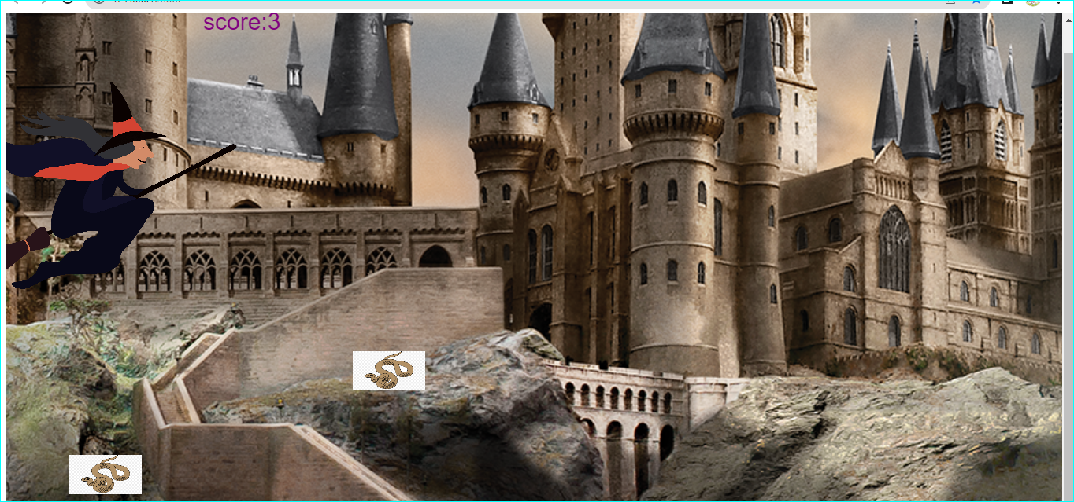

How do you plan to make your game engaging?

My plan is to add sound,rewards , score and obstacles to make the game

engaging